Ref: No: 50 / CEAD/ACABC/II/2025 Date: 17.11.2025
To,
Dr. Shahaji Sambhaji Phand
Principal Coordinator, AC&ABC
National Institute of Agriculture Extension Management (MANAGE)
Hyderabad – 500 030.

Subject: Submission of Valedictory Function Report – 2nd Batch AC&ABC Training Programme

Respected Sir,
We here with submit the Valedictory Function Report of the 2nd Batch of the Agri-Clinics and Agri-Business Centre (AC&ABC) Training Programme, conducted from 29.09.2025 to 17.11.2025, comprising 25 candidates, supported by MANAGE, Hyderabad
The Valedictory Programme was held on 17th November 2025 at CEAD.
Please find enclosed detailes of Valedictory Report along with photographs for your kind perusal and record.

With regards,

Dr. C. Ganeche
Nodal Officer – AC&ABC Scheme
CEAD, Puducherry

VALEDICTORY FUNCTION REPORT

AC&ABC Training Programme – Second Batch
Centre for Environment and Agricultural Development (CEAD), Puducherry
Date: 17th November 2025

1. Introduction
The Valedictory Function of the 45-Day Agri-Clinics and Agri-Business Centres (AC&ABC) Training Programme for the Second Batch (TP No.: 3061), conducted from 29 September 2025 to 17 November 2025, was organized on 17th November 2025 at 3.30 PM at the CEAD Training Hall, Thavalakuppam, Puducherry. The programme was sponsored by MANAGE, Hyderabad, under the Ministry of Agriculture & Farmers Welfare, Government of India. A total of 25 candidates was participated in the training.

2. Dignitaries Present
- Chief Guest:
• Thiru. R. Selvam, Honourable Speaker, Government of Puducherry

- Special Guests:
- Mr. R. V. Sidharthan, AGM (District Development), NABARD, Puducherry
- Mr. M. Vengata Subramanian, Zonal Manager, Indian Bank, Puducherry
- Mr. A. SATHISH Kumar, LDM, Indian Bank, Puducherry
- Ms. Sruthi Kulkarni, Consultant, MANAGE, Hyderabad

3. Programme Proceedings
3.1 Prayer – Tamil Thai Vazhthu
The ceremony commenced with the traditional Tamil Thai Vazhthu.
3.2 Welcome Address
Delivered by Mr. P. Manikandan, CEAD Puducherry.
3.3 Honouring of Dignitaries & Keynote Address
By Dr. C. Ganeche, Founder & Nodal Officer, AC&ABC Scheme, CEAD.
3.4 Training Report
Presented by Mrs. B. Sathya, Training Coordinator.
3.5 Participant Feedback
Trainees shared their experiences and feedback.
3.6 Felicitation & Special Addresses
By Ms. Sruthi Kulkarni (Online).
3.7 Special Address – NABARD
By Mr. R. V. Sidharthan. DDM - NABARD
and Mr. M. Vengata Subramanian, Zonal Manager, Indian Bank, Puducherry
3.8 Guest of Honour Address
By Dr. C. Ganeche, Founder & Nodal Officer, AC&ABC Scheme, CEAD
3.9 Chief Guest Address
By Thiru. R. Selvam.
3.10 Certificate Distribution
3.11 Vote of Thanks
By Mrs. B. Sathya, Training Coordinator.
3.12 National Anthem
Concluding the ceremony.
4. Conclusion
During the Valedictory Function, the dignitaries appreciated CEAD’s sustained efforts and commitment towards promoting Agri-Entrepreneurship. The trainees also expressed their gratitude for the comprehensive training and support received throughout the programme. CEAD assured that continued handholding, mentoring, and guidance will be provided to facilitate loan access and assist trainees in establishing their ventures.

Photo’s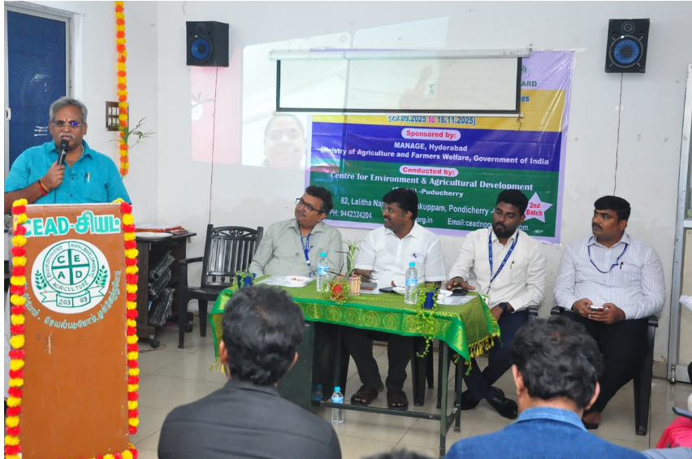
Thiru. R. Selvam, Honourable Speaker, Government of Puducherry

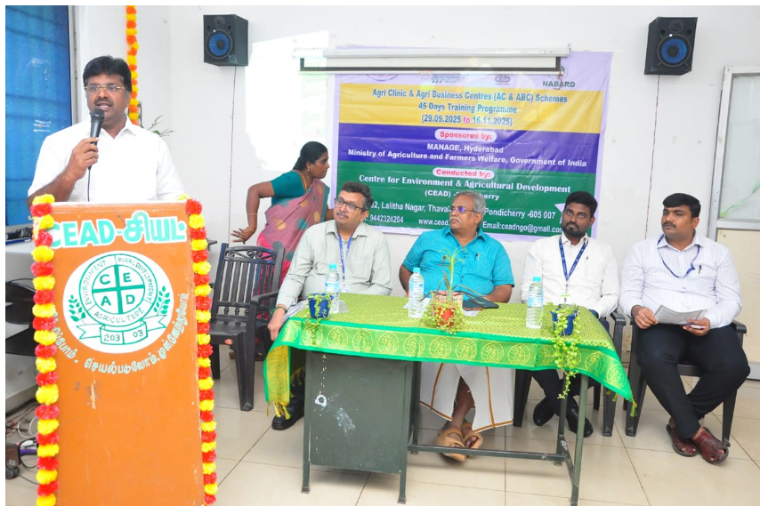
Dr. C. Ganeche, Founder & Nodal Officer, AC&ABC Scheme, CEAD

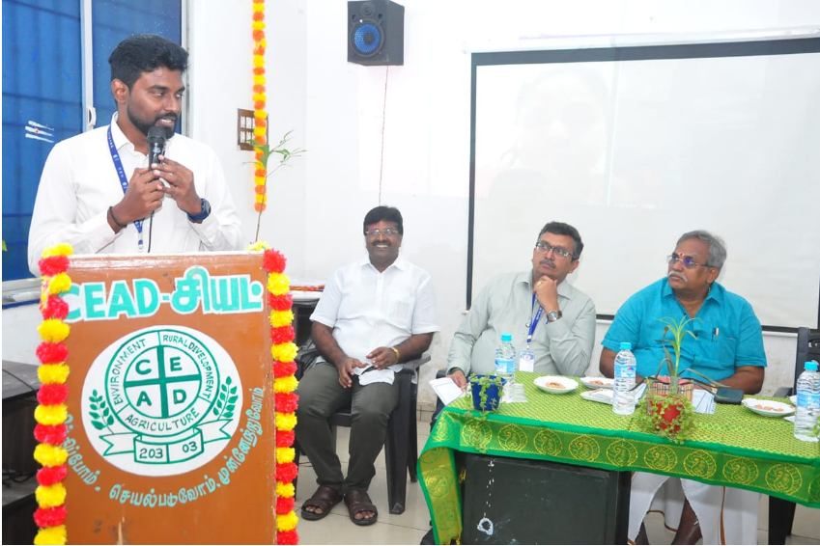
Mr. R. V. Sidharthan, AGM (District Development), NABARD, Puducherry

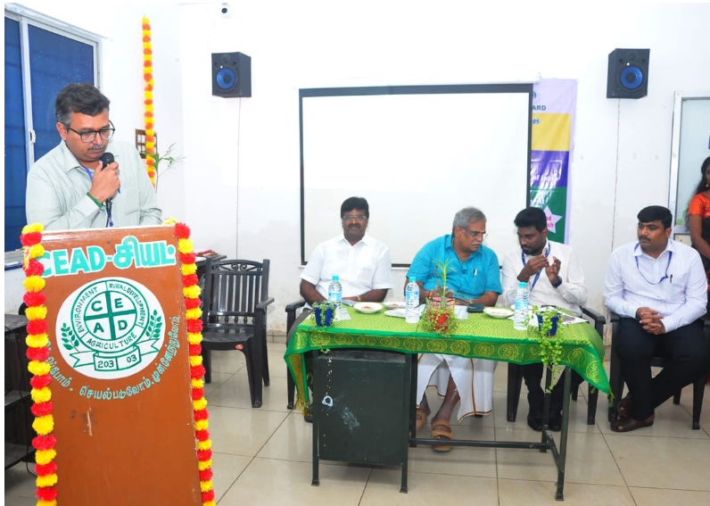
Mr. M. Vengata Subramanian, Zonal Manager, Indian Bank, Puducherry
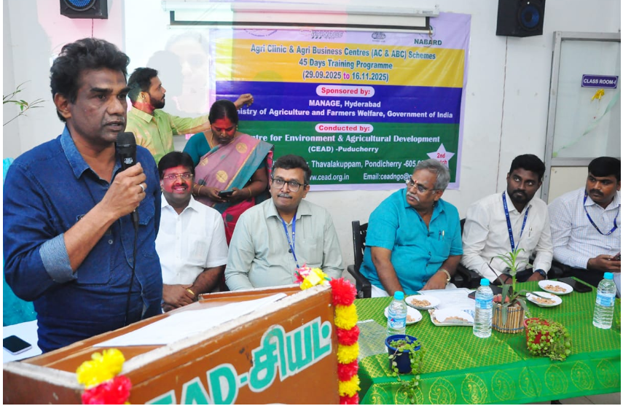
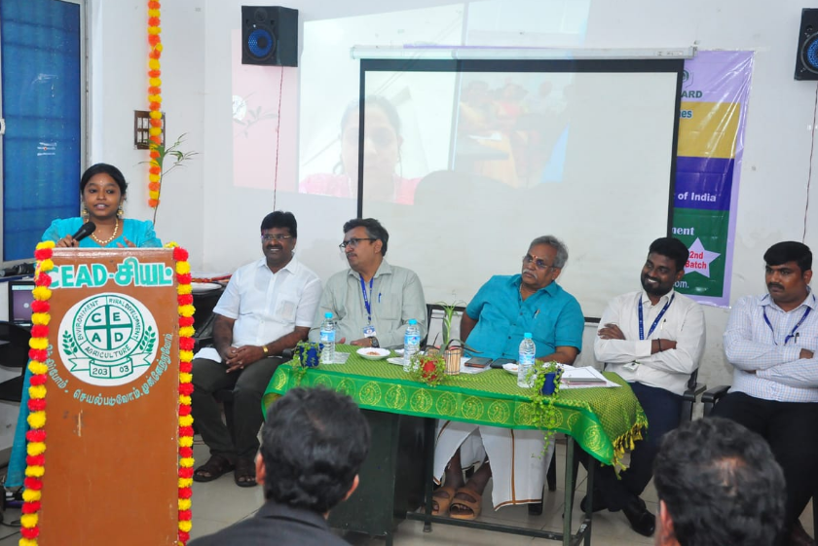
Participant Feedback
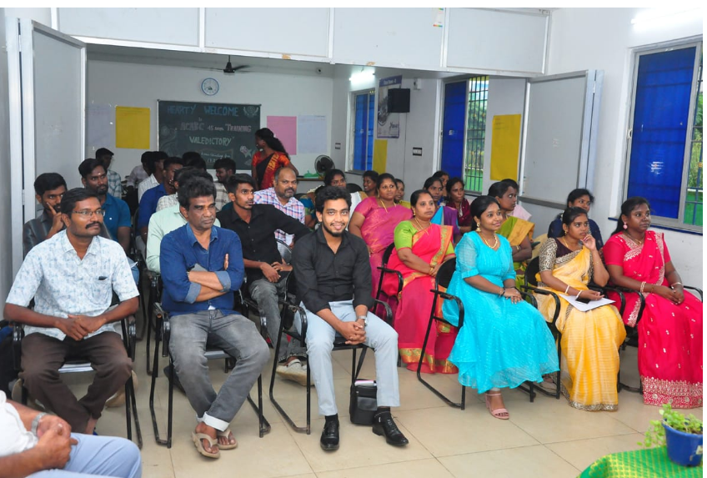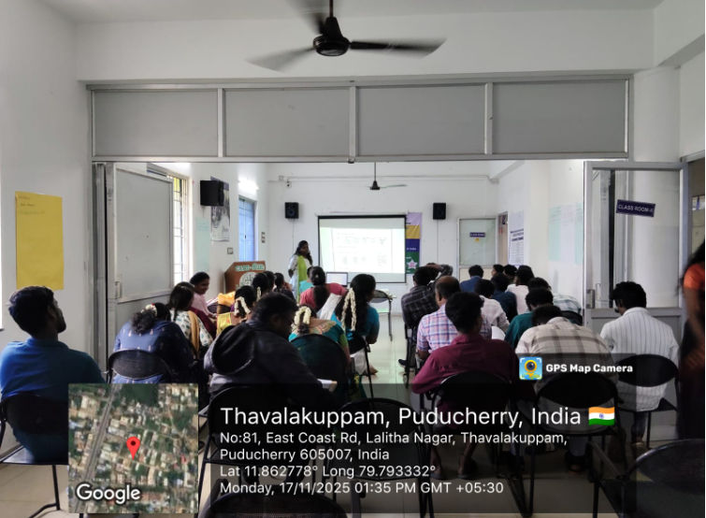
Participants

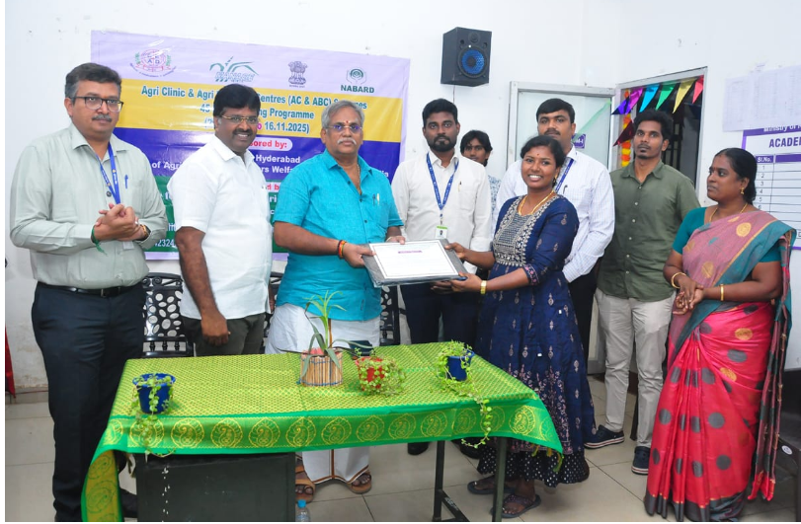
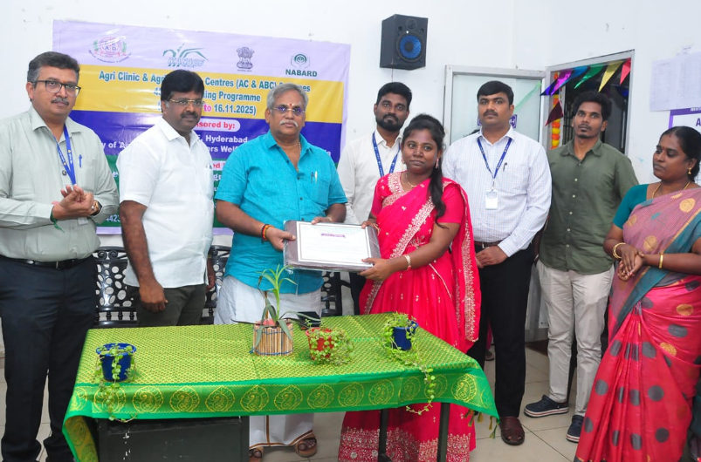
Best Participants

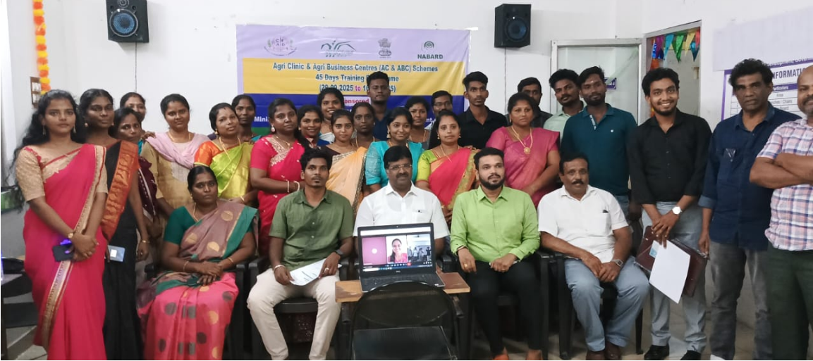
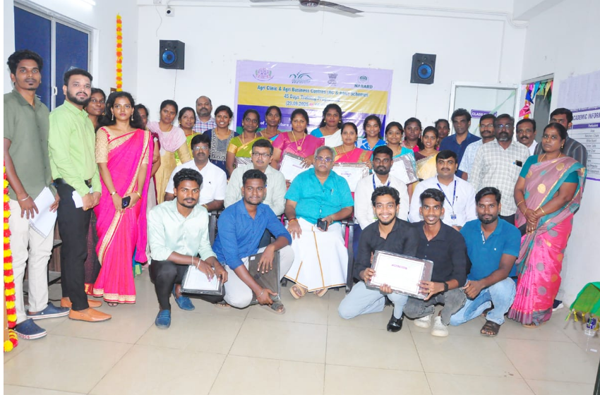
Group Photo

